


SOFTWARE DESIGN SPECIFICATION
Full Stack Web Development
CollegeCompass

Created By: | Shreya Panse | Approved By:
Created On: | 25-May-2025 | Approved On:

Page left blank intentionally

INDEX
1 PURPOSE 2
2 PROJECT SCOPE 2
3 SYSTEM OVERVIEW 2
4 DESIGN CONSIDERATIONS 2
4.1 Requirements 3
4.2 Assumptions 3
4.3 Dependencies 3
5 SYSTEM ARCHITECTURE 3
5.1 Architectural Strategies 4
5.2 Structure & Relationships 4
6 DETAILED DESCRIPTION OF COMPONENTS 4
7 INTEGRATION 5
8 APPENDICES 1
8.1 Appendix A – Detailed Description of Components 1

General Instructions for using the Live Project POC Document
- This template and the subsequent document created using this template is a confidential document and is the intellectual property of Cloud Counselage Pvt. Ltd. Circulating it outside of the organisation without the consent of Cloud Counselage Pvt. Ltd. is the breach of company policies and will lead to legal actions
- The Design Specification of a software forms the basis of development of software
- The text between inequality (< >) is to be replaced by relevant text
- Please remove the yellow highlight on the Text between the inequality (< >). This is done to help you notice the text to be changed/replaced
- The text in italics highlighted in grey is just for reference and should be removed after adding the relevant text

PURPOSE
This document is created based on the requirement specification document. The purpose of this Software Design Specification (SDS) Document is to break down the project into components to describe in detail what the purpose of each component is and how it will be implemented. The SDS will also serve as a tool for verification and validation of the final product.

PROJECT SCOPE
The scope of the CollegeCompass includes its distinct features, its benefits, and its limitations. The system's distinct features allow it to discover, filter and compare colleges based on entrance exam percentile, domain of interest and personal preferences by using HTML, CSS, JavaScript (frontend), Node.js with Express.js (backend), and MySQL (database). The system enables the user to find colleges they are eligible for based on their entrance exam score, compare them side by side, and view detailed information including cutoffs, fees, placements and campus data — all in one platform.

SYSTEM OVERVIEW
CollegeCompass is built using a three-tier architecture: a static HTML/CSS/JavaScript frontend, a Node.js and Express.js REST API backend, and a MySQL relational database. The frontend consists of four pages — landing.html (entry point with animations and quiz), index.html (explore page with search, filters and paginated college cards), college.html (single college detail view), and compare.html (side-by-side comparison). The backend exposes four REST API endpoints that query the MySQL database dynamically based on user-supplied filter parameters. The database contains seven tables — colleges, exams, courses, college_courses, cutoffs, placements and college_factors — storing data for 455 colleges across six domains. Data flows from the MySQL database through the Node.js API to the frontend via HTTP fetch calls. All pages communicate with the backend independently; there is no shared state between pages except for the compare list which is persisted in the browser localStorage.

DESIGN CONSIDERATIONS

Requirements
R1 — The system must allow students to filter colleges by entrance exam (JEE Main, JEE Advanced, CAT, NEET, BITSAT, CUET, GATE, SAT, IELTS, CLAT, NATA, UCEED). R2 — The system must filter colleges by percentile range, returning only colleges where min_percentile is less than or equal to the entered value and max_percentile is greater than or equal to the entered value. R3 — The system must filter colleges by domain (Engineering, Management, Medical, Law, Design, Arts). R4 — The system must filter colleges by college type (IIT, NIT, IIIT, IIM, Deemed, Private, State, Abroad). R5 — The system must filter colleges by country (India, Canada, Singapore, Australia, UK). R6 — The system must return paginated results of 20 colleges per page with a pagination object containing total, page, limit, totalPages, hasNext and hasPrev fields. R7 — The system must provide a college detail view showing cutoffs, placements, courses and campus information for each college. R8 — The system must allow comparison of up to 3 colleges side by side across 13 metrics. R9 — The system must allow sorting of results by NIRF rank, average package, fees and placement percentage. R10 — The system must display a landing page with hero section, exam ticker, how-it-works steps and feature cards.

Assumptions
A1 — Students are assumed to know their entrance exam percentile or rank before using the application. A2 — NIRF rankings are assumed to be the most credible and widely accepted ranking system for Indian colleges. A3 — Fees data for colleges imported from the NIRF CSV is estimated by college type since the NIRF dataset does not include fee information. A4 — The application is assumed to run on a machine with Node.js v20 or above and MySQL Server 8.0 or above. A5 — JoSAA 2025 cutoff data is not yet available; the application uses 2024 data as the most recent available source. A6 — Placement data is available and verified only for colleges with well-documented annual placement reports (currently 62 of 455 colleges). A7 — The browser used by students is assumed to support localStorage, fetch API and CSS animations (Chrome, Edge, Firefox, Safari — all modern versions).

Dependencies
D1 — The frontend depends on the Node.js backend server running on localhost:3000. If the server is not running all fetch calls fail. D2 — The backend depends on the MySQL database being running and populated before API queries can return data. D3 — The domain filter depends on records existing in the college_courses junction table. Colleges not linked to courses will not appear in domain-filtered results. D4 — The compare feature depends on the browser localStorage being enabled to persist the compare list across page navigations. D5 — The cutoff prediction feature (planned) depends on multi-year JoSAA data being imported into the cutoffs table. D6 — The AI chatbot feature (planned) depends on obtaining an Anthropic API key and available API credits. D7 — Production deployment depends on Railway (backend), Netlify (frontend) and Supabase or Railway PostgreSQL (database) accounts being created and configured.

SYSTEM ARCHITECTURE
The software system architecture refers to the logical organization of a distributed system into software components. It defines how components of a software system are assembled, their relationship and communication between them. It serves as a blueprint for software application and development basis for developer team. An effective architecture serves as the conceptual glue that holds every phase of the project together for all of its stakeholders, enabling agility, time and cost savings, and early identification of design risks.
The Software architecture:
- Defines structure of a system
- Defines behaviour of a system
- Defines component relationship
- Defines communication structure
- Balances stakeholder’s needs
- Influences team structure
- Focuses on significant elements
- Captures early design decisions

Below some important characteristics which are commonly considered are explained.
Operational Architecture Characteristics:
- Availability
- Performance
- Reliability
- Low fault tolerance
- Scalability

Structural Architecture Characteristics:
- Configurability
- Extensibility
- Supportability
- Portability
- Maintainability

Cross-Cutting Architecture Characteristics:
- Accessibility
- Security
- Usability
- Privacy
- Feasibility

Architectural Strategies
The CollegeCompass system architecture consists of the following major components: 1. Frontend Layer — Four HTML pages served statically: landing.html, index.html, college.html, compare.html. Shared helper functions in app.js. Styling embedded per page using CSS custom properties. Communication with backend via browser fetch() API. 2. Backend Layer — Node.js v20 runtime with Express.js v4 framework. Entry point: server.js. Route handlers in routes/colleges.js. Database connection pool in db.js. Environment configuration via .env using dotenv. 3. Database Layer — MySQL 8.0 relational database named college_finder. Seven tables: colleges, exams, courses, college_courses, cutoffs, placements, college_factors. Foreign key relationships enforced between junction tables and parent tables. 4. Data Import Layer — Node.js scripts: import.js (NIRF CSV to colleges table) and import_cutoffs.js (JoSAA CSV to cutoffs table). Run once per data refresh cycle. 5. REST API — Four endpoints: GET /colleges (filtered paginated list), GET /colleges/exams/all (exam list), GET /colleges/:id (full college detail), POST /colleges/compare (multi-college comparison). 6. Browser Storage — localStorage used to persist the compareList array across page navigations without requiring user authentication.

Structure & Relationships
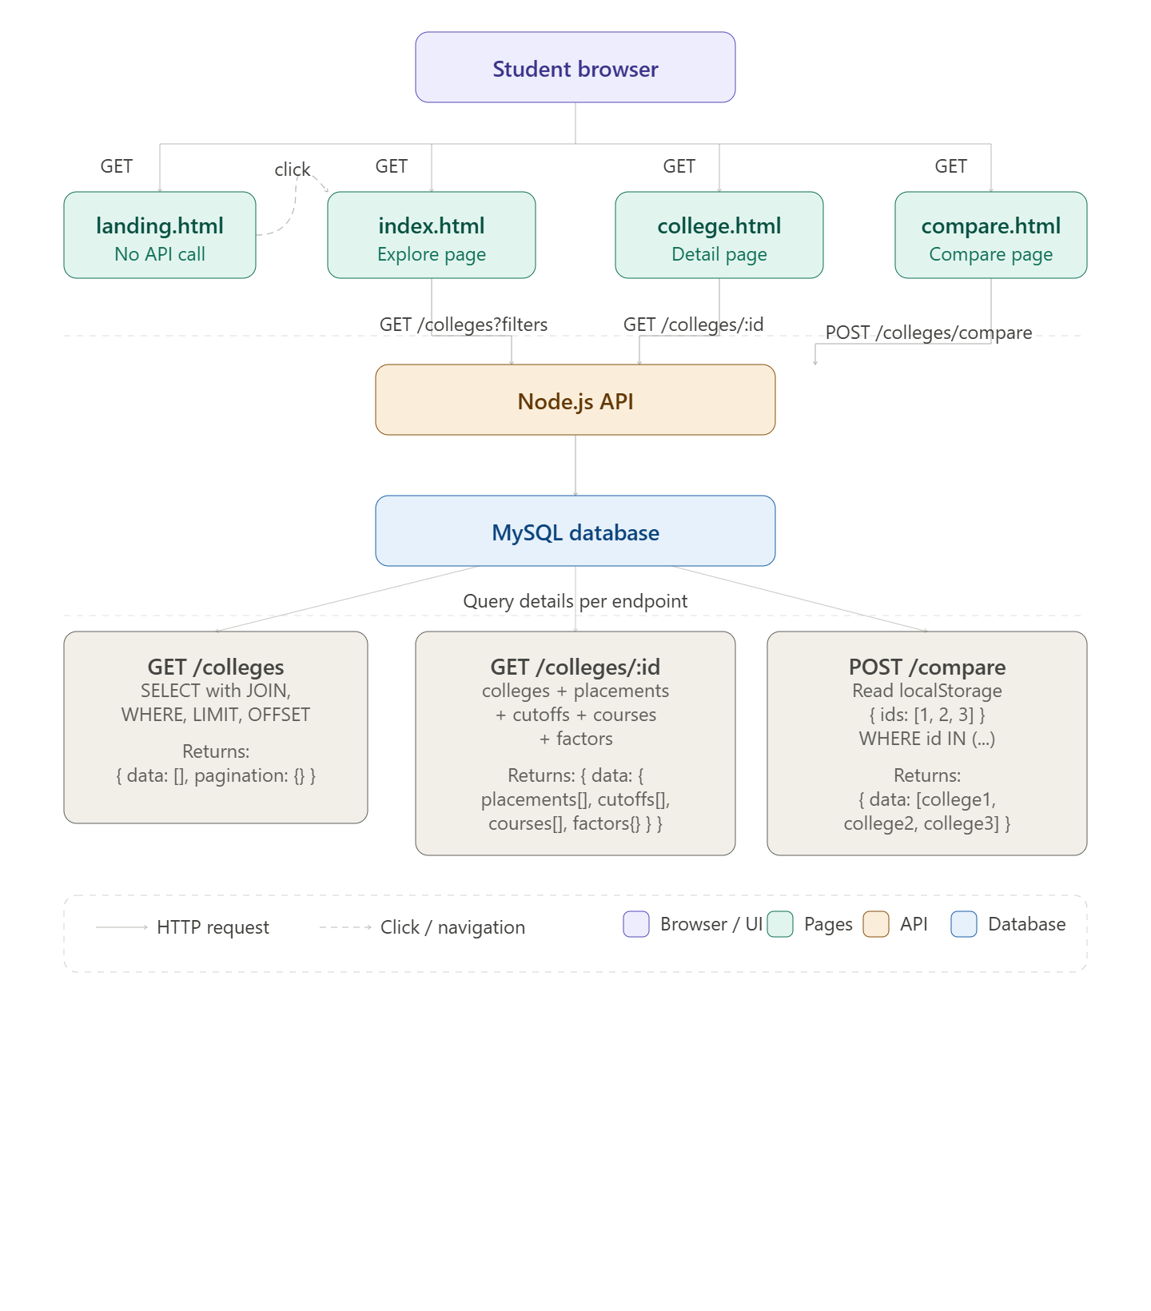

DETAILED DESCRIPTION OF COMPONENTS
For detailed description of the components, please refer Appendix A – Detailed Description of Components

The below template will be used to specify the details of all the components
Table 1: Detailed Design Specification Template
Identification | The unique name for the component and the location of the component in the system.
Type | A module, a subprogram, a form, a data file, a control procedure, a class, etc.
Purpose | Function and performance requirements implemented by the design component, including derived requirements. Derived requirements are not explicitly stated in the SRS - but are implied or adjunct to formally stated SDS requirements.
Subordinates | The internal structure of the component, the constituents of the component, and the functional requirements satisfied by each part.
Dependencies | How the component’s function and performance relate to other components. How this component is used by other components. The other components that use this component. Interaction details such as timing, interaction conditions (such as order of execution and data sharing), and responsibility for creation, duplication, use, storage, and elimination of components.
Interfaces | Detailed description of all external or internal interfaces as well as of any mechanism for communicating through messages, parameters, or common data areas. All error messages and error codes should be identified. All screen formats, interactive messages, and other user interface components (originally defined in the SRS) should be given here.
Resources | A complete description of all resources (hardware or software) external to the component but required to carry out its functions.
Processing | A full description of the functions presented in the Function subsection. Pseudocode can be used to document algorithms, equations, and logic.
Data | For the data internal to the component, describes the representation method, initial values, use, semantics, and format.

INTEGRATIONS
CollegeCompass integrates with the following external systems and tools: 1. NIRF India Rankings Portal (nirfindia.org) — Data source integration. The NIRF 2024 rankings CSV is downloaded manually from the NIRF portal or Kaggle and processed by import.js. The CSV contains institute ID, name, city, state, score and rank fields which are mapped to the colleges table columns. This is a one-way data flow: NIRF data is read and stored in the local MySQL database. No live API connection exists. 2. JoSAA Portal (josaa.nic.in) — Data source integration. JoSAA cutoff CSVs containing opening and closing ranks for IITs, NITs and IIITs are processed by import_cutoffs.js. Ranks are converted to percentiles using the formula: Percentile = (1 - Rank / Total Candidates) x 100. This is a one-way data flow into the cutoffs table. 3. MySQL 8.0 Database — The Node.js backend integrates with MySQL via the mysql2 npm package using a connection pool (createPool). Connection parameters (host, user, password, database) are stored in the .env file and loaded via the dotenv package. All SQL queries use parameterised statements (?) to prevent SQL injection. 4. Browser localStorage API — The frontend integrates with the browser localStorage API to persist the compareList array across page navigations. The compareList is serialised to JSON on write (JSON.stringify) and deserialised on read (JSON.parse). A try-catch wrapper handles browsers with localStorage disabled. 5. Google Fonts API — The frontend integrates with Google Fonts CDN (fonts.googleapis.com) to load the Playfair Display and DM Sans typefaces. This requires an internet connection. The fonts are loaded via a link tag in the HTML head of each page. 6. Planned — Anthropic Claude API — The AI chatbot feature planned for a future sprint will integrate with the Anthropic Claude API (api.anthropic.com/v1/messages) using the @anthropic-ai/sdk npm package. The backend will query the MySQL database for relevant colleges, pass the results as context to the Claude API, and return the AI-generated response to the frontend chat widget.

APPENDICES

Appendix A – Detailed Description of Components
Identification | colleges.js — API Route Handler
Type | Class/Form/
Purpose | Module — Express.js Router (routes/colleges.js)
Subordinates | Handles all HTTP requests related to colleges. Implements four REST API endpoints. Builds dynamic SQL queries based on query parameters. Communicates with MySQL via the db.js connection pool. Returns JSON responses to the frontend.
Dependencies | GET /colleges — returns filtered paginated college list. GET /colleges/exams/all — returns all exams. GET /colleges/:id — returns full college detail with nested placements, cutoffs, courses and factors. POST /colleges/compare — returns comparison data for 2-3 colleges.
Interfaces | Depends on db.js for the MySQL connection pool. Depends on the colleges, exams, courses, college_courses, cutoffs, placements and college_factors tables existing and being populated. Must be registered in server.js using app.use("/colleges", collegeRoutes).
Resources | Receives HTTP requests from the browser fetch() API. Accepts query parameters: exam, percentile, domain, type, country, page, limit. Returns Content-Type: application/json. Error responses return { success: false, error: message }. Success responses return { success: true, data: [], pagination: {} }.
Processing | Requires Node.js v20, Express.js v4, mysql2 npm package, and a running MySQL 8.0 instance. Connection parameters provided via .env file loaded by dotenv.
Data | Builds dynamic SQL using template literals with parameterised placeholders (?). Applies filters conditionally using if(param) checks. Uses LIMIT and OFFSET for pagination. Uses LEFT JOIN across 6 tables to assemble complete college data. Uses COUNT(DISTINCT c.id) for total record count.

Identification | MySQL Database — college_finder
Type | Class/Form/
Purpose | No persistent data stored in this component. All data retrieved from MySQL on each request. Query parameters validated by checking truthiness before appending to SQL. Page and limit parsed as integers with defaults (page=1, limit=20).
Subordinates | Data Store — MySQL 8.0 Database (college_finder)
Dependencies | Stores all college data in a normalised relational schema. Provides structured query support for filtered searches, joins across multiple tables, and aggregate operations. Serves as the single source of truth for all application data.
Interfaces | colleges table (455 records): id, name, city, state, country, type, nirf_rank, fees_per_year, website, about. exams table (12 records): id, name, full_name, type. courses table (23 records): id, name, domain, duration_years. college_courses table: junction linking colleges to courses. cutoffs table: college_id, exam_id, year, min_percentile, max_percentile. placements table: college_id, year, avg_package_lpa, highest_package_lpa, placement_percentage. college_factors table: college_id, has_hostel, has_international_exchange, research_score, campus_size_acres.
Resources | Depends on MySQL Server 8.0 being installed and running. Depends on import.js and import_cutoffs.js having been run to populate data. Queried exclusively by colleges.js via the db.js connection pool using the mysql2 library.
Processing | Accessed by the Node.js backend via TCP connection on port 3306. Connection credentials stored in .env (DB_HOST, DB_USER, DB_PASSWORD, DB_NAME). Uses connection pooling (connectionLimit: 10) for efficient multi-request handling. All queries use parameterised statements to prevent SQL injection.
Data | Requires MySQL Server 8.0 or above installed on the host machine. Requires MySQL Workbench for visual administration and data verification. Connection managed by mysql2 npm package in Node.js backend.

See components 1-6 above covering all system layers of CollegeCompass.

